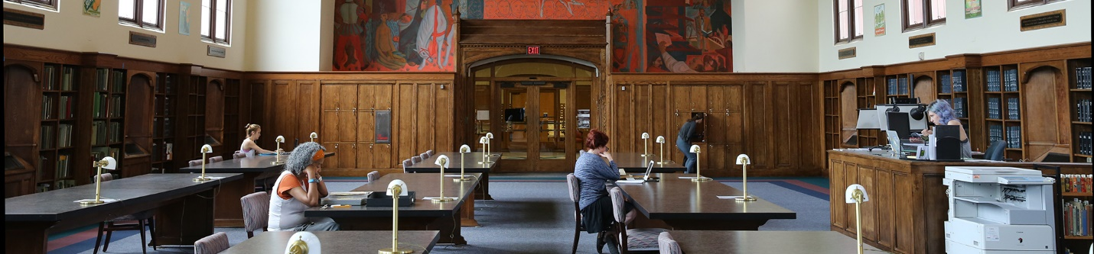

Department of Special and Area Studies Collections
George A. Smathers Libraries University of Florida
Call for Travel to Collections Proposals
http://www.uflib.ufl.edu/spec

AN INVITATION TO TRAVEL TO OUR REPOSITORY: Travel grants of up to $2000 will be awarded to undertake research activities in Special and Area Studies Collections. http://library.ufl.edu/spec/

Proposals are due Friday, April 28, 2017. Submissions should be directed to Florence M. Turcotte turcotte@ufl.edu. Awardees will be notified of the outcome of the proposal review process on or by June 1, 2017.

Projected budgets should include:
- Transportation costs to and from Gainesville
- Housing costs for a maximum of two weeks
- Costs of reprographics or other services needed to conduct your research

GUIDELINES
- Interdisciplinary research and/or using more than one collection will be prioritized
- Proposals that support the production of a tangible outcome (article, dissertation, monograph) will be prioritized
- Awardees must use collections onsite for at least 2 weeks (10 working days)
- Each awardee is required to submit a brief report (~500 words) describing their research visit by the end of the cycle (June 30, 2018). This statement may be used for promotions related to the collections.
- Each award is distributed after the report and payment paperwork have been submitted.
- Awardees must be traveling 100 miles or farther to use the collections.
- Date of research trip should be coordinated with appropriate curatorial staff. Research may be conducted July 1, 2017 through June 30, 2018.

Submissions must include the following:
- A title and description of your proposed research project (no more than 600 words), with identification of relevant materials to be consulted.
- A one-sentence statement affirming applicant’s commitment to submit a report at the end of the travel cycle, with permission to publish or use for promotions.
- Applicant’s cv or resume.
- Applicant’s name, postal address, telephone number, and a valid email address.
- A budget estimate for travel, lodging and other expenses.

QUESTIONS? If you have questions about the suitability of your proposal, or need information on any aspect of the program, please contact Flo Turcotte by phone (352-273-2767) or by email (turcotte@ufl.edu).

